This voucher(s) includes a taxable (speaker fee, honorarium, etc) along with a non-taxable payment (travel reimbursement, meals, etc) this voucher will need to have TWO invoice lines (NOT distribution lines) to separate these amounts for 1099 reporting required by the University. The voucher(s) will need to be unposted by Accounting in order to correct it. Once you receive notification that the voucher has been unposted - you MUST make the corrections the SAME day as voucher posting is run each night.

Accounts Payable –> Vouchers –> Add/Update –> Regular Entry –> Click the “Find an Existing Value” Tab and enter your voucher # in the voucher ID field and click on search.

Change the invoice lines to “2” by clicking on the “+” icon (be sure to select the one under invoice line not distribution line). This will allow you to enter the taxable compensation (speaker fee, honorarium, etc.) on one invoice line and the non-taxable (travel expenses, etc.) on the second line.

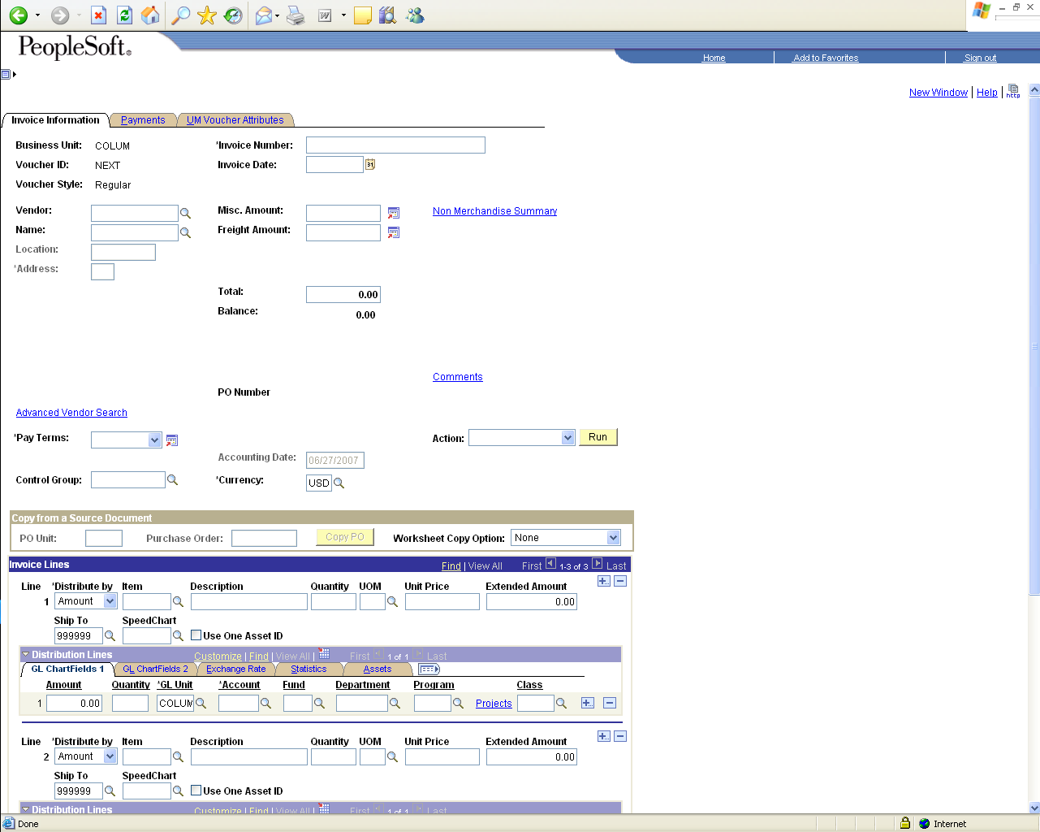

To have your voucher UNPOSTED please contact our Accounting Services HelpDesk at 882-3051.

Feel free to call if you have any questions. Thanks.

