UM System AHJ Code Determination

Code Determination Number: 14
Date: April 8, 2024
Code Edition: 2021 IBC, ASCE/SEI 7-16, 2109 NFPA 13
Code Section: IBC Chapters 16 and 17, ASCE/SEI 7-16 Chapter 13, NFPA 13 Chapter 18: seismic bracing design requirements and special inspections for nonstructural components (re. plumbing, mechanical, electrical, fire sprinkler systems, storage rack systems).
Subject: Determining Seismic Design Category and Special Inspection requirements for non-structural components.

Questions (from various UM Staff and Design Consultants):

How do I determine what the seismic design category is for my project?

When are special inspections for seismic resistance needed for non-structural building components (plumbing, mechanical, electrical, storage racks, sprinklers, etc.)?

What needs to be provided on the drawings for Seismic Design and special inspection requirements?

Is there a specification available?

Answer (from UM AHJ):

The answers that follow are provided in a tutorial format for ease of understanding.
- The IBC requires earthquake design data (seismic information) to be included in the construction drawings regardless if the information applies to structural design or not (ref IBC 1603.1.5). Many project scopes of work do not affect the building structure itself, but seismic bracing may still be required for the building infrastructure and system components.

- Determining the Seismic Design Category (SDC): this involves three factors
- the mapped spectral response parameters or software based mapping results
- the site classification (re. a soils classification provided by a formal geo tech report, or a presumptive classification per code)
- the Building Risk Category (I, II, III, or IV – see the Risk Category table in IBC Chapter 16)

Users can use online Seismic Design calculators to quickly determine the proper SDC. Links are provided below.

ASCE 7 Hazard Tool

U.S. Seismic Design Maps (seismicmaps.org)
- Using online seismic design classification tools:
- Use the following city and state for the various campuses: MU- Columbia, Mo., MS&T- Rolla, Mo., UMSL- Ferguson, Mo., UMKC- Kansas City, Mo. (Note: for off campus projects recenter the map to the project location or enter the name of the closest town)
- Select the correct version of the ASCE 7 design standard (the current version is ASCE 7-16).

Note: the 2024 IBC, once adopted, will reference the ASCE 7-22.
- Select the building risk category: (per IBC table 1605.4).

Note: most campus buildings will fall under a Risk Category III rating (re. a building with an occupancy load >500 people, or assembly use >300). Group I-2, Condition 2 with emergency surgery or treatment, for example, would be a Risk Category IV. In many cases the higher risk category (IV) will increase the SDC category due to the need to increase the survivability and continued operations and services of these facilities.

- Select the site classification:

Enter the site classification category from the geo tech report. If a geo tech report is not available for the particular building site, the code requires an assumptive site classification of D (ref. IBC 1613.2.2). Do not rely on geo tech report information from a nearby building site as the soils on our campuses are continually being disturbed which effects the classifications.
- Once this information is entered, run the report. The Seismic Design Category will be displayed in the report description.
- Enter the results on the permit application and code information plan sheet (re. information for Siesmic Design Category and Site Classification fields).

- Determining seismic special inspection requirements for non-structural components:
- Review IBC Chapter 17 to identify applicable special inspection requirements for MEP, Sprinkler, and Storage racks (code snips shown at the end of this document).
- Review NFPA 13, Chapter 18 to identify flexible coupler, sway bracing, and other sprinkler system requirements.
- Review ASCE 7-16, Section 13.1.3 to apply an Importance Factor (Ip) of “1.5” where required. The typical support/ bracing design calculations are based on an Importance Factor of “Ip =1.0”. (Life safety systems such as sprinkler systems and egress stairways, Risk Category IV structures, Harzardous Occupancies, and others require an elevated Importance Factor of “Ip = 1.5” in an effort to provide more robust support/bracing capabilities).
- ASCE 7-16, Chapter 13, also inlcudes exemption statements, and detailed design information for use by consultants and delegated designers.
- Ensure the Importance factor (Ip) information is shown in the project drawing special inspection table(s), and editable fields of specification 20 0800.
- Table of Seismic Special Inspections:
- Once the list of special inspections are determined, insert a table of special inspections for non-structural components in the project drawings (sample tables are shown at the end of this document).

- Specification for non-structural component seismic bracing:
- Consultants should use Specification 20 0800 Seismic Protection and insert this document into the project manual.
- This specification contains several editable fields, based on: calculated seismic design category information, systems involved in the project scope of work, Seismic design criteria, and Importance Factor determinations.
- Design criteria entered into the specification shall match the data shown in the Seismic Design calculator and the information shown in the project drawings (a sample 20 0800 specification is linked at the end of this document).

- Exceptions: Per IBC 1704.2, Exception 2, special inspections are not required for Use Group U occupancies. Confirm proper Use Group determination with the consultant, an inspector, or the UM AHJ, as required.

- Delegated design of non-structural component seismic bracing: The University allows delegated deign for seismic bracing, vibration and seismic controls for fire suppression piping, mechanical, electrical, plumbing systems, and storage racks. Confirm approval with the campus Project Manager during the initial construction document design phases.

Snips from 2021 IBC, Chapter 17 (required special inspections for MEP, sprinkler systems, and storage racks)
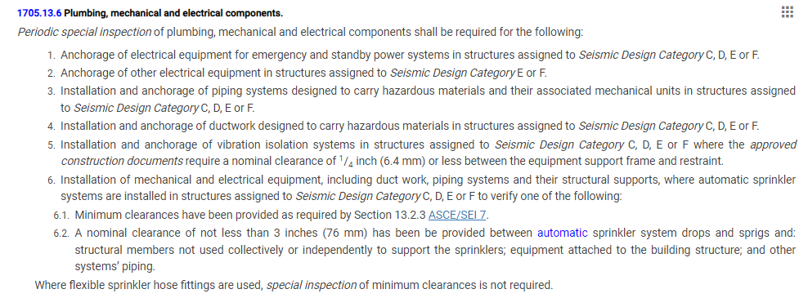
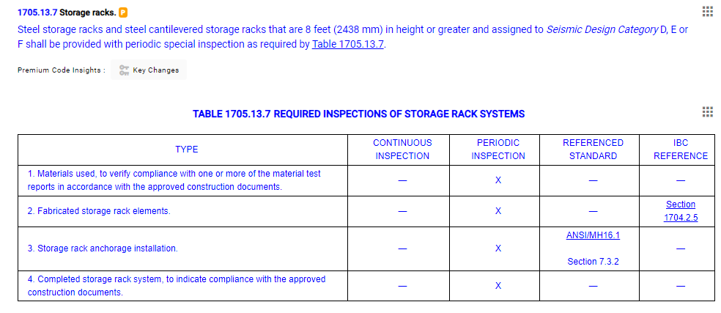

Sample Mechanical Equipment Component Earthquake Load Resistance table:
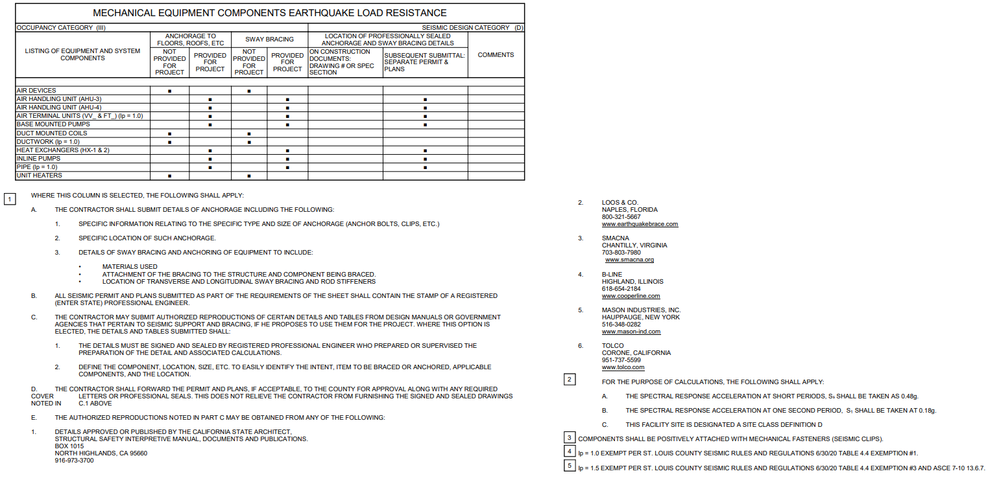

Sample Fire Alarm and Lighting seismic bracing table:
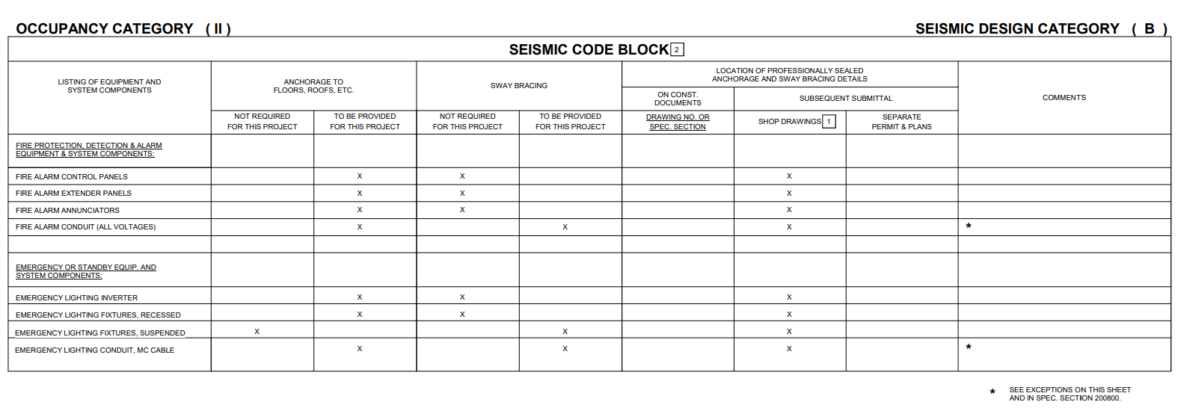

SPECIFICATION 20 0800

End of Document

