­­

Code Determination Number: 04

Date:   June 9, 2020

Code Edition: 2018 IBC

Code Section: 111.3 Temporary Occupancy

Subject: Extension of a Temporary Certificate of Occupancy

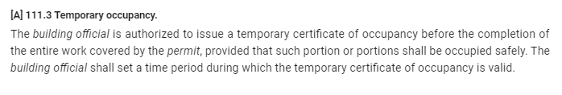

# Question (from GBA):

Is a temporary certificate of occupancy allowed to be extended past the 30-day period? If so, what is the procedure?

# ****Answer (from UM System):****

The UM AHJ allows an inspector to issue a Temporary Certificate of Occupancy (TCO) per IBC 111.3. For construction projects: this certificate could be used to allow the Owner to take acceptance of a portion of the construction project or accept planned phasing of the construction work as it is completed. ***All life, health, and safety items must be complete and free of any violation, for the portions of work covered in the Temporary Certificate of Occupancy.***

We have established a maximum 30-day expiration time frame for TCO’s. This matches our contractual requirements stating that the project must be ‘completed’ within 30 days of substantial completion.

Smaller projects, or projects performed by “in house construction”, where a construction contract was not issued, can have a shorter TCO expiration time frame based on the inspector’s findings during the TCO inspection.

The established maximum expiration time frame re-enforces the importance of correcting the remaining code violations, completing the project in a timely manner, and closing out the building permit.

An extension should only be granted on a case by case basis and must have just cause. A reinspection shall be performed to verify the remaining code violations/discrepancies prior to granting an extension. Any extension shall be limited to a maximum of 15 days. Any applicable reinspection fees shall be borne by the Contractor as described in the General Conditions (unless the cause for the delay is due to needs of the Owner).

Other uses for a Temporary Certificate of Occupancy: where a “Conditional Use Building Permit” is being issued to allow a temporary change of use, special use, or limited time frame use, the Temporary Certificate of Occupancy can be issued with an expiration date equal to the permit duration. Consult with the UM AHJ for clarification and recommendations in these instances.

Lastly, a Certificate of Occupancy (Temporary or Final) can be revoked per the provisions in IBC 111.4.