Code Determination Number: 03

Date: May 11, 2020

Code Edition: 2018 IBC

Code Section: 111

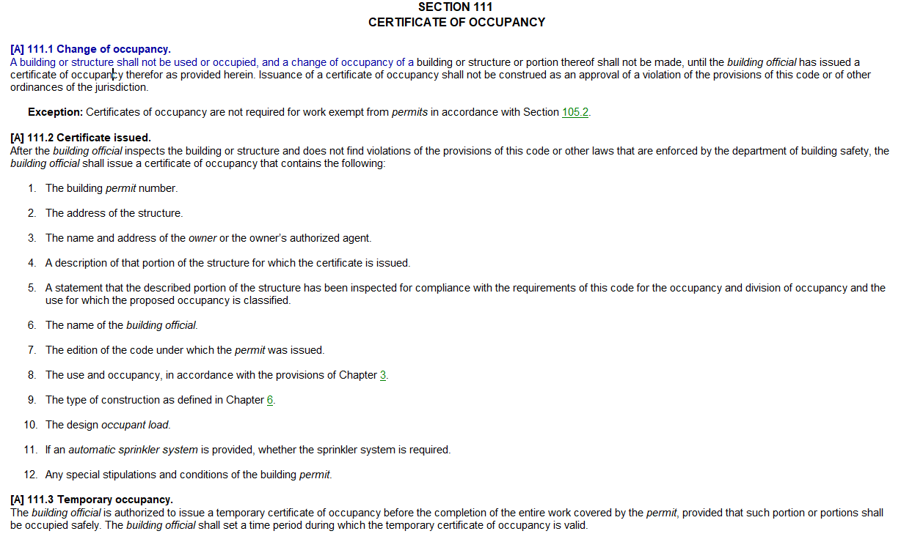

**Question (from various Campus and Agency personnel):**

Are Certificates of Occupancies required for all University projects? What type of project would require TCO’s or FCO’s? How do we issue Certificate of Occupancies for phased projects?

**Answer (from UM System):**

Any project which includes changes or upgrades to the building’s life, health, safety (LHS) systems, or ADA elements, and those where an occupancy change, or occupant load change has occurred will need a Certificate of Occupancy prior to the Owner occupying the building.

Utility projects and many maintenance/repair projects will not need a Certificate of Occupancy- a final inspection report will suffice.

For projects with intentional phased completion: a TCO/FCO should be issued for each phase if the phased work area has human occupancy and is intended to be occupied upon completion. If Phase 1 is, for example, the building shell, and Phase 2 is for building fit out- provide a final inspection report for Phase 1, and a final inspection and TCO/FCO for Phase 2, as each phase would be permitted separately.

Note: A Temporary Certificate of Occupancy is valid for a maximum of 30 calendar days from date of issuance, per current policy. A reinspection must take place and the project should be ready for Final Occupancy within this 30 day timeframe.

**Examples: (certificates of occupancy versus final inspection report)**

1. In general, renovations and new construction where the work area is occupied will require a final inspection and TCO/FCO.
2. The project converts general office space into a classroom(s): a final inspection and TCO/FCO are required (occupant load, egress and F/A changes may be required).
3. Repairs to or construction of steam chases and duct banks: a final inspection report is all that is required (no human occupancy)
4. Adding new A/V devices to an existing office, conference room, or classroom spaces: a final inspection report is all that is required (no changes to occupancy or loads, or LHS systems).
5. A three phase project for renovating office suites 101, 102, and 103. When 101 is complete, construction will commence on 102, etc.: A TCO/FCO needs to be issued in addition to the final inspection at the completion of each phase, since human occupancy and Owner use is expected immediately upon the completion of each phase.
6. Replacing or upgrading pumps, mechanical or other equipment: a final inspection report is all that is required (limited scope of work and no impact to human occupancy).
7. A two phase project where the Owner does not intend to occupy the work area(s) until Phase 2 is complete: issue a final inspection report for Phase 1, and a final inspection and TCO/FCO upon completion of Phase 2.
8. The project contains life, health, safety or ADA upgrades (new sprinkler, fire alarm devices, compliant hand rails, compliant exterior stairs/entrances, etc.): a final inspection and TCO/FCO are required.
9. Converting general offices to cube space: a final inspection and TCO/FCO will be required (apparent changes to occupancy loads and potential for egress element changes).
10. The project renovates an existing parking lot where the lot will be resurfaced, restriped, and add 4 new ADA designated parking spaces: a final inspection report is all that is required (though this project includes potential ADA upgrades, the users are “outside” the building- no impact to building occupants, therefore a TCO/FCO is not necessary).