­­

Code Determination Number: 01

Date:   April 20, 2020

Code Edition: 2018 IBC

Code Section: 1705.12.6

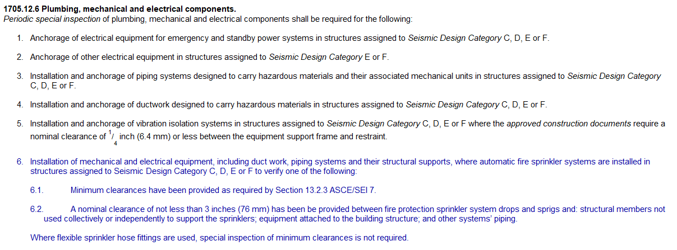

# Question (from GBA):

If an MU Facility contains a sprinkler system and is designated as Seismic Design Category D, does UM System expect this Special Inspection to be performed in accordance with the code section listed above?

# ****Answer (from UM System):****

Yes, and whether the scope of the project is major or minor, we would expect both categories to be inspected. There will be instances where seismic support/bracing would be a delegated design item for sprinkler piping, plumbing piping, suspended equipment, etc., so those items need deferred submittal review and subsequent inspection. Those of a minor nature could be inspected by a building inspector or the RDPRC. Services of a Special Inspector may not be required for minor scopes of work. The preference would be for the building inspector to inspect those of a minor nature in an effort to provide a timely and more cost effective inspection. If the RDPRC is to perform, the Owner should anticipate a longer lead time for scheduling the inspection and incurring an additional site visit fee.